OLOL XC Summer Running Log 20XX
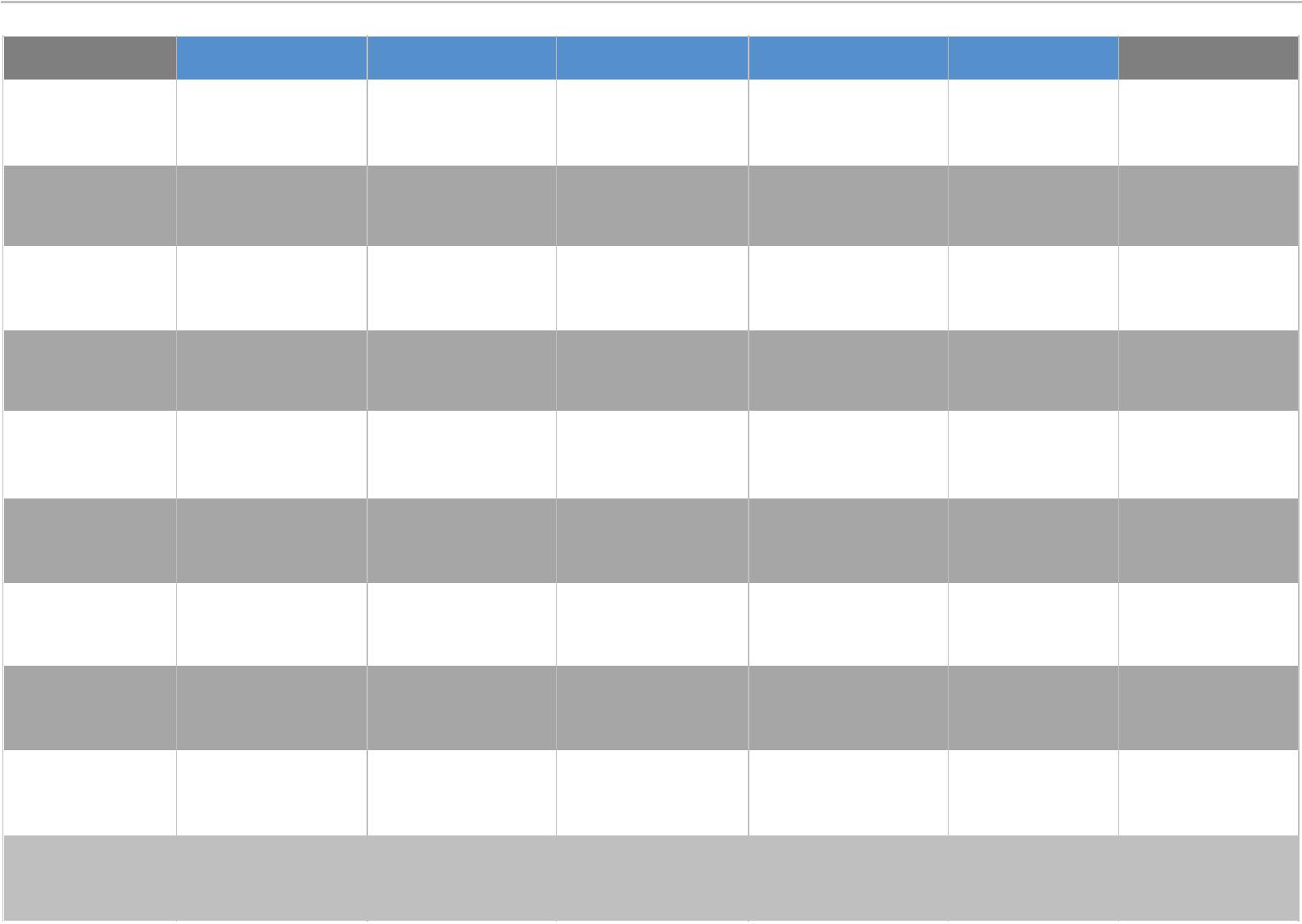

 | Sun | Mon |  | Tues |  | Wed |  | Thurs |  |  | Fri | Sat
 |  |  |  |  |  | June 1 | 2 |  |  |  | 3 | 4
5 |  | 6 | 7 |  | 8 |  | 9 |  |  |  | 10 | 11
12 |  | 13 | 14 |  | 15 |  | 16 |  |  |  | 17 | 18
19 |  | 20 | 21 |  | 22 |  | 23 |  |  |  | 24 | 25
26 |  | 27 | 28 |  | 29 |  | 30 |  |  |  | July 1 | 2
3 |  | 4 | 5 |  | 6 |  | 7 |  |  |  | 8 | 9
10 |  | 11 | 12 |  | 13 |  | 14 |  |  |  | 15 | 16
17 |  | 18 | 19 |  | 20 |  | 21 |  |  |  | 22 | 23
24 |  | 25 | 26 |  | 27 |  | 28 |  |  |  | 29 | 30
31
Mileage Club Membership |  |  |  | Runner’s Name: _______________________________
1st Graders = 10 miles
2nd Graders = 20 miles |  |  |  | I pledge on my honor that I ran a total of ________ summer miles.
3rd Graders = 30 miles
4th Graders = 40 miles |  |  |  | Runner Signature: _________________________________
5th Graders = 50 miles
6th Graders = 60 miles |  |  |  | Parent Signature: ___________________________________
7th Graders = 70 miles
8th Graders = 80 miles

